Given a m x n matrix mat and an integer threshold. Return the maximum side-length of a square with a sum less than or equal to threshold or return **0** if there is no such square.

**Example 1:**

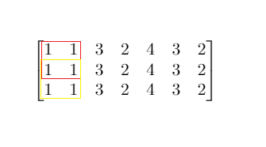

**Input:** mat = [[1,1,3,2,4,3,2],[1,1,3,2,4,3,2],[1,1,3,2,4,3,2]], threshold = 4

**Output:** 2

**Explanation:** The maximum side length of square with sum less than 4 is 2 as shown.

**Example 2:**

**Input:** mat = [[2,2,2,2,2],[2,2,2,2,2],[2,2,2,2,2],[2,2,2,2,2],[2,2,2,2,2]], threshold = 1

**Output:** 0

**Example 3:**

**Input:** mat = [[1,1,1,1],[1,0,0,0],[1,0,0,0],[1,0,0,0]], threshold = 6

**Output:** 3

**Example 4:**

**Input:** mat = [[18,70],[61,1],[25,85],[14,40],[11,96],[97,96],[63,45]], threshold = 40184

**Output:** 2

**Constraints:**

* 1 <= m, n <= 300
* m == mat.length
* n == mat[i].length
* 0 <= mat[i][j] <= 10000
* 0 <= threshold <= 10^5